Hi Sunny –

Change of plans on which project to work on next…

Instead, I would like to switch gears and instead prioritize OHLC data requests using IEX. I found a medium article where someone walks through how to accomplish such as thing:

<https://medium.com/wealthy-bytes/free-financial-stock-data-for-python-using-iex-api-f8ed1d0b5108>

My overall goal is the same as before… I’d like to be able to pull data for the entirety of the S&500 into a dataframe (where the close prices for each ticker are saved in a column corresponding to the ticker name).

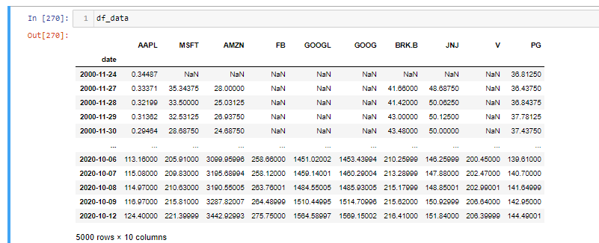

My goal is to be able to pull data for the entire S&P500 in under 1-minute from January 1, 2010 – present. I am not sure if IEX will be able to sustain this, but I would like to try. Interactive Brokers has been great for trading and other portfolio management needs but requesting data from their platform can be tedious. I think this may be a better bet. I have tried yahoo data as well… but the problem with Yahoo is that their server will throttle the connection after 20-50 requests, so it doesn’t turn out to be a good solution for the entire 500 stocks of the S&P 500 (yahoo is great for a few stocks, but not a large quantity).

I have also been evaluating various paid APIs… but still have not found a suitable option.

Anyways, can we run a test with IEX and see if its feasible to pull historical data for 400-500 tickers quickly? If not, we do not need to spend much time here. But if it does work out… then we can build out a reasonably in-depth API wrapper for various data needs.